Link: <https://dev.mysql.com/downloads/windows/installer/8.0.html>

Step 1:

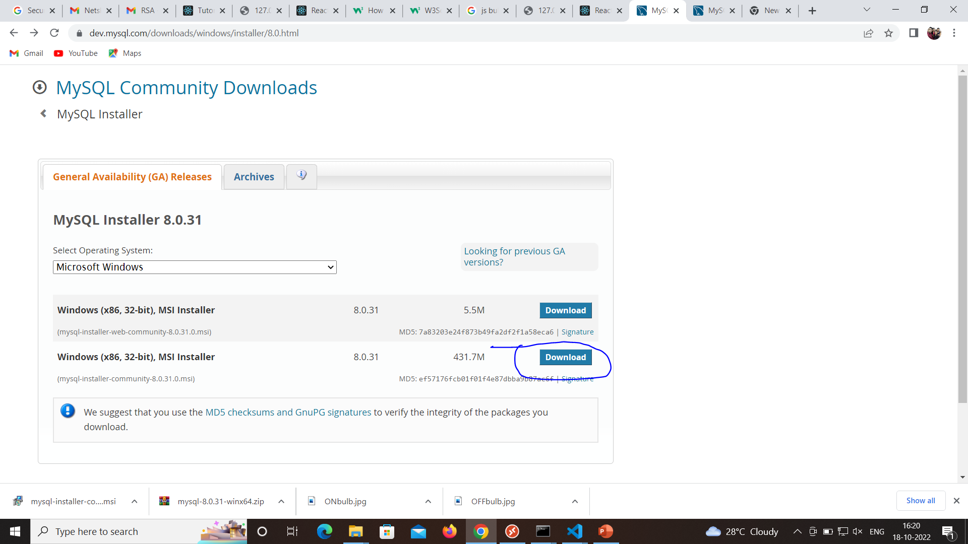

Step 2

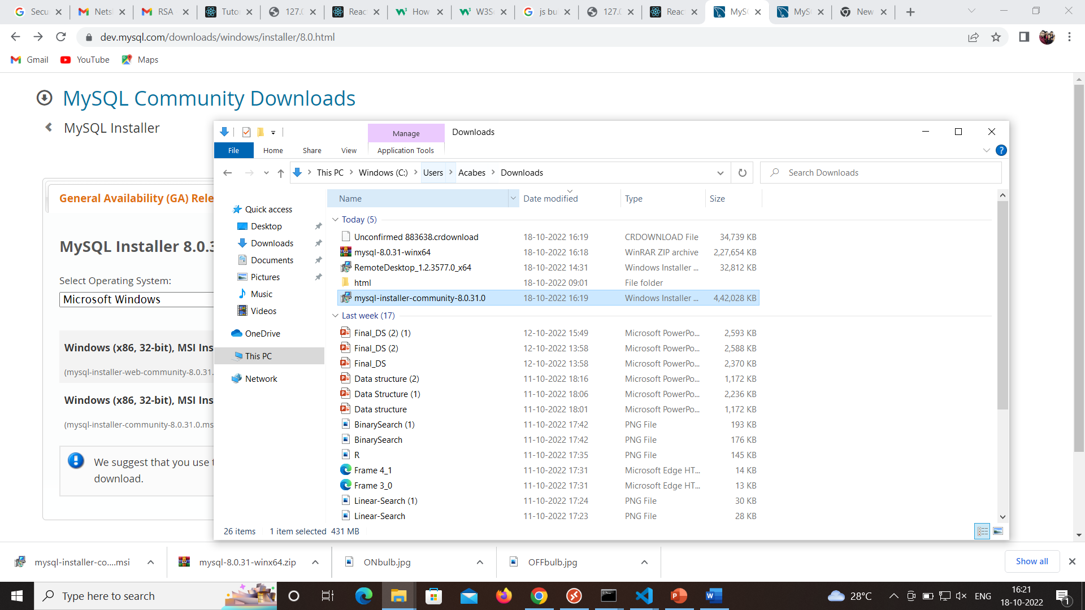

Step 3

